A1341-ME- Canaanite-Byblos-Temple aux Obélisques-Late Bronze Age-1550-1200 BCE

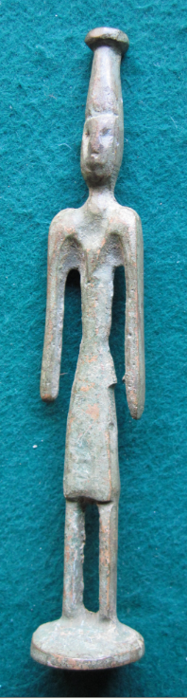 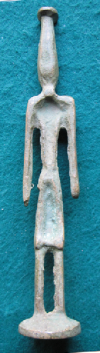 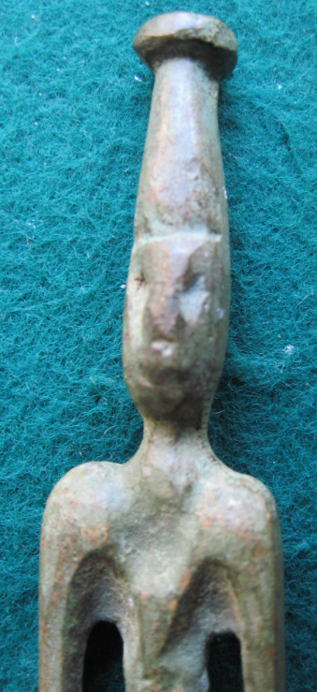 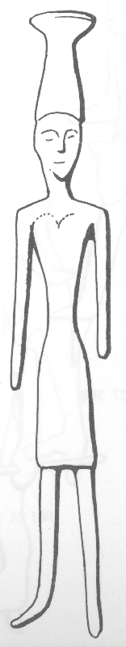

Figs. 1-3. Canaanite-Byblos-Temple aux Obélisques-Late Bronze Age-1550-1200 BCE

Fig. 4. Canaanite-Byblos-Temple aux Obélisques-Late Bronze Age-1550-1200 BCE after **Negbi 1976, p. 22, fig. 29, no. 530.**

**Case no.: 3**

**Accession Number: A1341**

**Formal Label:** Canaanite-Byblos-Temple aux Obélisques-Late Bronze Age-1550-1200 BCE **Display Description:**

This bronze statuette is solid-cast, standing with feet apart ending in a platform. Both arms are unbent ending in unsculpted hands. There are no missing weapons and attributes. His face has pinched eyes defined by incision, a prominent nose, protruding lips and a rounded chin. Ears are not shown.

The figure is wearing the white crown of Upper Egypt and a short kilt and belongs to the Byblo-Egyptian Group that contains nearly 700 specimens from Byblos, all with high headgear reminiscent of a set of joined figurines from Byblos and also similar to several Syro-Phoenician figurines. The finest figurines of this group recall the Egyptian kings wearing the ‘white’ crown of Upper Egypt as portrayed in wooden statuettes of the 12th Dynasty (Kenyon 1966:50; Hansen 1969: 281).

**LC Classification:** DS121.4

**Date or Time Horizon:** Late Bronze Age-1550-1200 BCE

**Geographical Area:** Byblos-Temple aux Obélisques

**Map, GPS coordinates:** [34°07′25″N 35°39′04″E](https://tools.wmflabs.org/geohack/geohack.php?pagename=Byblos&params=34_07_25_N_35_39_04_E_type:city_region:LB-JL)

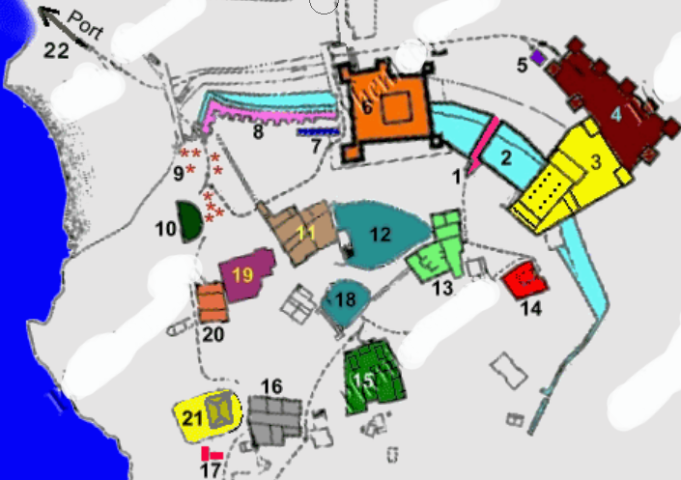

1- City gate (3rd millennium BC)

2- Primitive rampart (-2500)

3- Achaemenid Podium

4- Fortress

5- Byzantine Mill

6- Crusader castle

7- Rampart (2nd millennium)

8- Rampart sawtooth (3th millennium)

9- Royal Tombs (2nd millennium)

10- Roman Theatre

11- Temple of Baalat-Gebal

12- Sacred pond & basins terracotta

13- L Temple

14- Obelisks Temple

*15- Enclosure & pre-urban houses*

*16- Great residence*

17- Neolithic houses

18- Fountain

19- Amorite Quarry

*20- Pre-amorite residence*

*21- Contemporary house*

*22- Port*

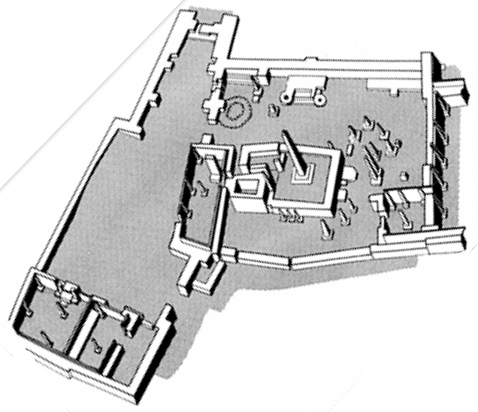 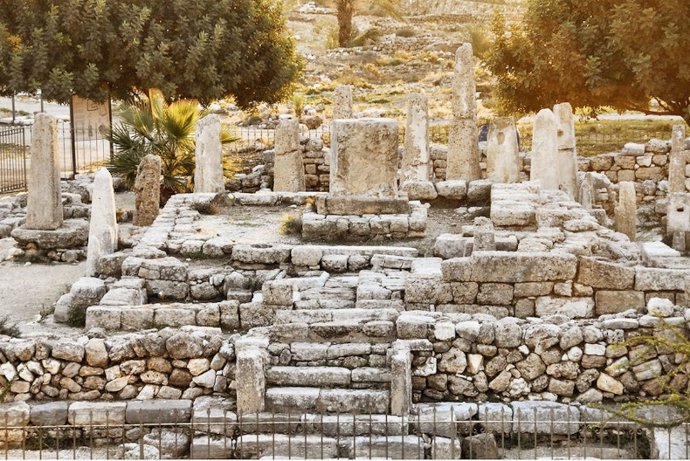

Fig. 5. Byblos-Temple aux Obélisquesfrom <http://anabases.revues.org/docannexe/image/849/img-8-small580.png>.

Fig. 6. Byblos-Temple aux Obélisquesfrom http://antikforever.com/Syrie-Palestine/Phenicien%20Cananeen/Images/byblos14b.jpg

**Cultural Affiliation:** Canaanite

**Media:** Bronze. Item cleaned, waxed and solidified professionally.

**Dimensions:**

**Weight:**

**Condition: original. This statuette is similar to one from** Byblos-Temple aux Obélisques, in **Negbi 1976, p. 22, fig. 29, no. 530.**

**Provenance:** procured in Jerusalem, 1960’s.

**Discussion:**

The deity depicted is likely Ba‘al who personified royal power and authority. Much of our knowledge about Canaanite gods comes from the local Canaanite literature, particularly from the archive of cuneiform tablets from the site of Ugarit. The Canaanite deities continued to be worshipped during the first millennium BCE, although some of their functions changed. They were worshipped wherever the Canaanites established trading colonies across the Mediterranean.

**References:**

Hansen, D. P. 1969. “Some remarks on the chronology and style of the objects from Byblos,” *American Journal of Archaeology*, 73:281-284.

Kenyon, Kathleen. 1966. *Amorites and Canaaites*. The Schweich Lecture 1963. London.

Negbi, Ora. 1976. *Canaanite gods in metal: an archaeological study of ancient Syro-Palestinian figurines.* Publications of the Institute of Archaeology; no. 5. Tel Aviv: Tel Aviv University, Institute of Archaeology.